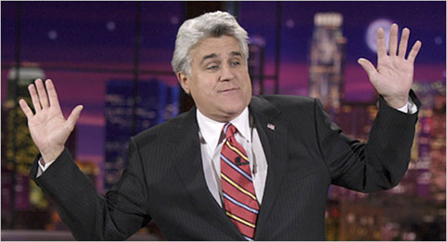Paul Drinkwater/NBCU Photo Bank Jay Leno on the set of “The Tonight Show.”

